CIA-1

Question 1:

Code:

package com.example.main.testing.Day5;

import org.openqa.selenium.By;

import org.openqa.selenium.Keys;

import org.openqa.selenium.WebDriver;

import org.openqa.selenium.chrome.ChromeDriver;

import org.openqa.selenium.chrome.ChromeOptions;

import io.github.bonigarcia.wdm.WebDriverManager;

public class CIA1

{

public static void main( String[] args ) throws InterruptedException

{

ChromeOptions co = new ChromeOptions();

co.addArguments("--remote-allow-origins=*");

WebDriverManager.*chromedriver*().setup();

WebDriver driver = new ChromeDriver(co);

driver.manage().window().maximize();

driver.get("https://www.amazon.in/dp/B0BY8JZ22K?ie=UTF8&ref_=tile1_OPCE3Lite&pf_rd_r=S5EQV3N10Q8DQ4F8GRYX&pf_rd_p=f9b21fd0-f4b0-4df8-8ed7-1a63a309f7ce&pd_rd_r=92dc3dfb-5330-4526-8123-2ec298750f3a&pd_rd_w=8tozG&pd_rd_wg=GzWLa&th=1");

String title = driver.getTitle();

String p_name = "OnePlus Nord CE 3 Lite 5G (Pastel Lime, 8GB RAM, 128GB Storage)";

System.***out***.println(title);

if(title.equals(p_name)) {

System.***out***.println("Title is matching");

}

else {

System.***out***.println("Title Mismatch");

}

driver.findElement(By.*xpath*("//*[@id=\"add-to-cart-button\"]")).click();

Thread.*sleep*(5000);

Boolean present = driver.findElement(By.*xpath*("//*[@id=\"attach-close_sideSheet-link\"]")).isDisplayed();

System.***out***.println("item added to cart:" + present);

driver.get("https://www.amazon.in/gp/cart/view.html/ref=dp_atch_dss_cart?");

Thread.*sleep*(5000);

driver.findElement(By.*xpath*("//*[@value=\"Delete\"]")).click();

Thread.*sleep*(5000);

String removeText = driver.findElement(By.*xpath*("//*[@id=\"sc-active-cart\"]/div/div[1]/div/h1")).getText();

String text = "Your Amazon Cart is empty.";

if(removeText.equals(text)) {

System.***out***.println("Product is removed");

}

driver.get("https://www.amazon.in/dp/B0BY8JZ22K?ie=UTF8&ref_=tile1_OPCE3Lite&pf_rd_r=S5EQV3N10Q8DQ4F8GRYX&pf_rd_p=f9b21fd0-f4b0-4df8-8ed7-1a63a309f7ce&pd_rd_r=92dc3dfb-5330-4526-8123-2ec298750f3a&pd_rd_w=8tozG&pd_rd_wg=GzWLa&th=1");

driver.findElement(By.*xpath*("//*[@id=\"add-to-cart-button\"]")).click();

Thread.*sleep*(2000);

driver.get("https://www.amazon.in/gp/cart/view.html/ref=dp_atch_dss_cart?");

Thread.*sleep*(5000);

driver.findElement(By.*xpath*("//*[@id=\"a-autoid-0-announce\"]")).click();

driver.findElement(By.*xpath*("//*[@id=\"quantity_2\"]")).click();

Thread.*sleep*(2000);

driver.findElement(By.*xpath*("/html/body/div[1]/div[2]/div[3]/div[5]/div/div[1]/div[1]/div/form/div/div[3]/span/span/span/input")).click();

Thread.*sleep*(1000);

driver.findElement(By.*xpath*("//*[@id=\"ap_email\"]")).sendKeys("ravinandhini44@gmail.com",*Keys*.***ENTER***);

driver.findElement(By.*xpath*("//*[@id=\"ap_password\"]")).sendKeys("tokamak@",*Keys*.***ENTER***);

String sign = driver.getTitle();

System.***out***.println(sign);

String esign = "Amazon Sign In";

if(sign.equals(esign)) {

System.***out***.println("Success");

}

else {

System.***out***.println("Failure");

}

}}

Screenshots:

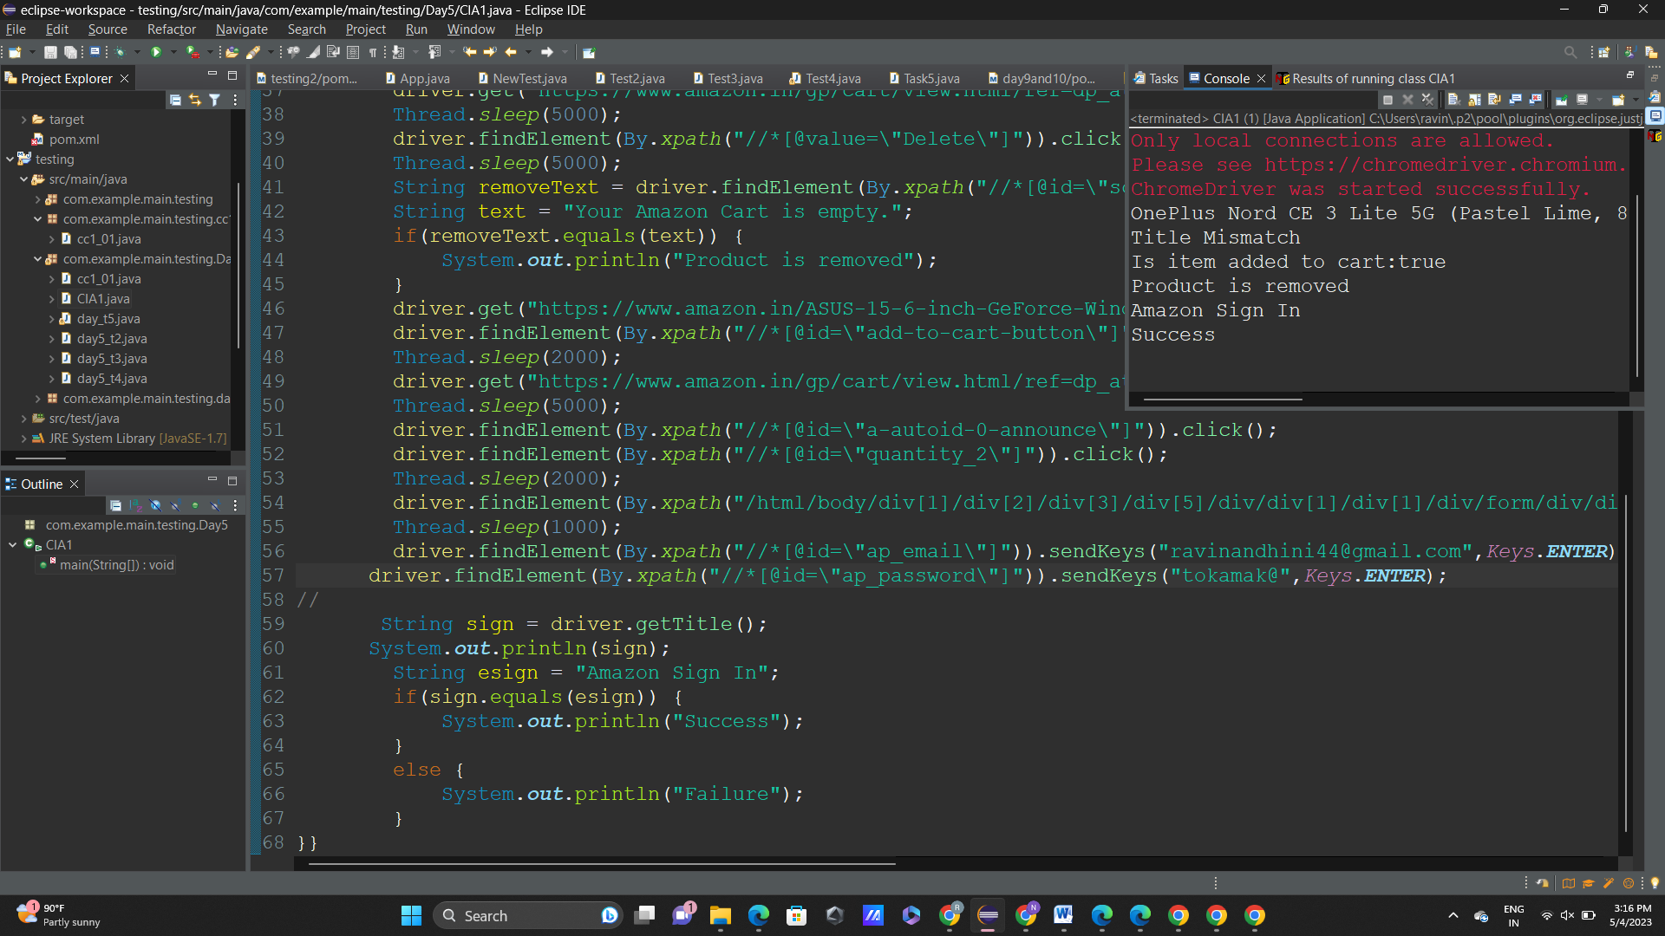

Question-2:

Code:

package com.example.main.testing.Day5;

import org.openqa.selenium.By;

import org.openqa.selenium.WebDriver;

import org.openqa.selenium.WebElement;

import org.openqa.selenium.chrome.ChromeDriver;

import org.openqa.selenium.chrome.ChromeOptions;

import org.openqa.selenium.edge.EdgeDriver;

import io.github.bonigarcia.wdm.WebDriverManager;

public class CIA_2 {

public static void main(String[] args) {

WebDriverManager.*edgedriver*().setup();

WebDriver driver = new EdgeDriver();

driver.get ("https://www.amazon.in/");

driver.manage().window().maximize() ;

//search product

WebElement search=driver.findElement(By.*xpath*("//*[@id=\"twotabsearchtextbox\"]"));

search.sendKeys("hp");

driver.findElement(By.*xpath*("//*[@id=\"nav-search-submit-button\"]")).click();

//displaying names

String txt1=driver.findElement(By.*xpath*("//*[@id=\"search\"]/div[1]/div[1]/div/span[1]/div[1]/div[3]/div/div/div/div/div/div/div/div[2]/div/div/div[1]/h2/a/span")).getText();

System.***out***.println(txt1);

String txt2=driver.findElement(By.*xpath*("//*[@id=\"search\"]/div[1]/div[1]/div/span[1]/div[1]/div[4]/div/div/div/div/div/div/div/div[2]/div/div/div[1]/h2/a/span")).getText();

System.***out***.println(txt2);

String txt3=driver.findElement(By.*xpath*("//*[@id=\"search\"]/div[1]/div[1]/div/span[1]/div[1]/div[5]/div/div/div/div/div/div[2]/div/div/div[1]/h2/a/span")).getText();

System.***out***.println(txt3);

String txt4=driver.findElement(By.*xpath*("//*[@id=\"search\"]/div[1]/div[1]/div/span[1]/div[1]/div[6]/div/div/div/div/div/div[2]/div/div/div[1]/h2/a/span")).getText();

System.***out***.println(txt4);

String txt5=driver.findElement(By.*xpath*("//*[@id=\"search\"]/div[1]/div[1]/div/span[1]/div[1]/div[7]/div/div/div/div/div/div[2]/div/div/div[1]/h2/a/span")).getText();

System.***out***.println(txt5);

//filter

driver.findElement(By.*xpath*("//*[@id=\"p_36/7252032031\"]/span/a/span")).click();

driver.findElement(By.*xpath*("//*[@id=\"p_n_pattern_browse-bin/1464446031\"]/span/a/span")).click();

}

}

Screenshots:



Question-3:

Code:

package com.example.main.testing.Day5;

import org.openqa.selenium.By;

import org.openqa.selenium.Keys;

import org.openqa.selenium.WebDriver;

import org.openqa.selenium.WebElement;

import org.openqa.selenium.chrome.ChromeDriver;

import org.openqa.selenium.chrome.ChromeOptions;

import org.openqa.selenium.edge.EdgeDriver;

import io.github.bonigarcia.wdm.WebDriverManager;

public class CIA_3{

public static void main(String[] args) throws InterruptedException {

WebDriverManager.*edgedriver*().setup();

WebDriver driver = new EdgeDriver();

driver.get ("https://www.amazon.in/");

driver.manage().window().maximize() ;

driver.findElement(By.*xpath*("//*[@id=\"nav-link-accountList\"]")).click();

driver.findElement(By.*xpath*("//*[@id=\"ap_email\"]")).sendKeys("ravinandhini44@gmail.com",*Keys*.***ENTER***);

driver.findElement(By.*xpath*("//*[@id=\"ap_password\"]")).sendKeys("tokamak@",*Keys*.***ENTER***);

Thread.*sleep*(10000);

driver.findElement(By.*xpath*("/html/body/div[1]/header/div/div[5]/div[1]/a/i")).click();

Thread.*sleep*(1000);

driver.findElement(By.*xpath*("/html/body/div[3]/div[2]/div/ul[1]/li[27]/a")).click();

Thread.*sleep*(1000);

String url = driver.getCurrentUrl();

if(url.equals("https://www.amazon.in/gp/css/homepage.html?ref_=nav_em_ya_0_1_1_29")) {

System.***out***.println("account details fetched");

}

else {

System.***out***.println("account details not fetched");

}

Thread.*sleep*(10000);

String url2 = driver.getCurrentUrl();

driver.findElement(By.*xpath*("/html/body/div[1]/div[2]/div/div[2]/div[1]/a/div/div/div/div[2]/h2")).click();

if(url2.equals("https://www.amazon.in/gp/your-account/order-history?ref_=ya_d_c_yo")) {

System.***out***.println("order details fetched");

}

else {

System.***out***.println("order details not fetched");

}

}

}

Screenshots:

